# 5. FINANCING

*This section looks at how the City financed Hammarby’s development and sold land to developers for property development. The section is divided into four sections:*

* *The financial mechanisms for land allocation*
* *The responsibilities and funding mechanisms for the development process*
* *The two business models for infrastructure development in Hammarby Sjöstad,*
* *The two funding sources for the development’s key environmental projects.*

## 5.1 Land Allocation

It is in the interest of theDevelopment Administration to manage the land of the City of Stockholm in an effective, economic, and environmentally friendly way. The Development Administration must look for a long-term housing solution that attracts current and future inhabitants. The Development Administration must take into consideration the developers and other actors' interest to participate and contribute to the development of the future Stockholm. It is a mutual give and take. **Any proposal for new land allocation on land owned by the City of Stockholm is always prepared in close cooperation between the Development Administration and the Office for City Planning.**

Land for condominiums and land for rental units are dealt with differently. Land for condominiums is sold at market prices whereas land for rental units is leased through leaseholds. A leasehold is a contract where the base rent is heavily subsidized by the government. The value of the leasehold today is about 1/3 of the actual market value. If a developer with a leasehold instead wants to purchase and acquire the land, it must be converted to market price. If a developer wants to lease directly through a tenant and the Board approves the change of tenure form, the land is sold for market price (Administration Development, Land Allocation Policy).

The City of Stockholm can use three different methods when selling land through land allocation to interested clients. The three methods are tendering, direct land allocation, and land allocation competitions.

* **Tendering:** The municipality gives the land allocation to the builder who has offered the most money for the land.
* **Direct land allocation:** The developer makes a proposition for how to develop the land. If the idea is attractive to the municipality, the municipality could allocate that piece of land to the developer. Today, there is an established price level in the area, which is why direct allocations are common. The projects are usually quite small, with 50-70 apartments (Skillbäck, 2015).
* **Land allocation competition**: The municipality announces a competition. The developers make propositions and the municipality awards the land allocation to the builder that has the best idea. In Hammarby Sjöstad, there have been a few land allocation competitions. In principle, this should reward developers that have more innovative ideas for green technology, but most of the propositions were in the end chosen based on which developers could provide the most money. For other developments, this strategy for land allocation could be refined and improved. However, the additional funding that this competition raised was important so that the City could reward public housing companies as well as smaller tenancy builders in order to get mixed income housing (Skillbäck, 2015).

## 5.2 Financing for Development Process

This section covers the party responsible for each step of the development process in terms of financing and how that party financed their responsibilities. The flow chart below shows the general process for development used in Hammarby. The City Government, developers, and residents are the main actors.

*Figure 1. Process from Land Development to Property Ownership in Hammarby. Source: Authors*

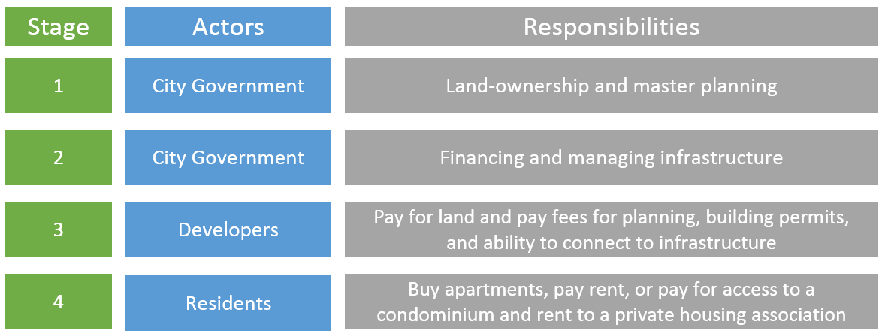

The next table provides more details on the actors, their responsibilities, and the financing tools used at each stage.

*Table 9. Responsibilities and Financing for Implementation of Hammarby*

|  |  |  |  |  |
| --- | --- | --- | --- | --- |
| **Stage** | **Role** | **Party** | **Responsibility** | **Financing** |
| 1 | Land Ownership and Master Planning | *City Government* | The municipality is in charge of (1) Creating Detailed Plans; (2) Building permits; and (3) Property registration. | Through plan agreements and fees paid by the construction companies. |
| 2 | Financing and Managing Infrastructure | *City Government* | The municipality is in charge of (1) Preparing the ground for construction and sanitation or remediation of soil; (2) Building and maintaining streets and parks, (3) Building waste and sewage systems; (4) Selling the land to property owners for development; (5) Coordinating the construction and building of the area. | Expansion of the area is financed via land sale to public or private developers. The management of streets and parks are tax financed. |
| *Stockholm Landsting (County of Stockholm)* | The county of Stockholm was in charge of the development of the tram line that runs through Hammarby Sjöstad. They are still responsible for managing it. | The expansion of the tram line was financed through tax and ticket revenues. |
| *Government Infrastructure Companies* | Manage and operate water and sewage, district heating, electricity, gas, telecommunications, fiber net, and garbage. The next figure shows the company that corresponds with each technology. | The expansion of technical infrastructure is financed through facility fees paid by the developers. Operation and maintenance costs are financed through running charges paid by the property owners. |
| 3 | Building, developing, and managing residential and commercial properties | *Developers* | Building and developing residential and commercial properties | Building costs are paid for by the developers themselves |
| *Property owners* | Manage their own facilities. For the vacuum waste system, some owners joined together in a club to manage it. | The residents pay a monthly fee to the property owner (rent for the apartment) that in turn finances some of the expenses of the property. |
| 4 | Using and living in residential units | *Residents* | Pay for access to residential units or to live in residential units. | Residents pay for their own units, or pay for access to a condominium to be able to rent out the unit to a private housing association. |

The table above shows the key parties involved in the development process of Hammarby. The following sections go into more detail on each of these stages.

For ***Stage 2***, there are a number of regulations that come into play when the City of Stockholm sells land to a developer in Hammarby Sjöstad. The City of Stockholm and the developers each have their own financing responsibilities. There are also responsibilities that these two parties manage jointly.

*Table 1. Responsibilities of the City of Stockholm and Developers Related to Land Sales*

|  |  |
| --- | --- |
| *The City of Stockholm* | * **Conditions for purchasing land area**: The City decides purchase price, access, payments and informs the developers; * **Land use:** The City calculates the approximate amount of dwellings as well as communicates the overall plans of the area with the developers. In the case of Hammarby, it was in this early phase that the City introduced the sustainable development goals and the associated design principles; * **Relocation of pipes:** The City provides and pays for the relocation of existing pipes that must be moved in order to build on the land. |
| *Developers* | * **Construction costs:** Responsible for the design and the construction costs within the land area as per the City’s requirements; * **Waste disposal management:** Developers should connect their land to a communal facility for underground waste transportation. The developers are responsible for financing the installation of the vacuum waste system; * **Park and vegetation:** Responsible for protecting trees and vegetation; * **Storm water**: Primarily taken care of by developers in the area. If that is not possible, there is a chance to connect the storm water to the Stockholm Water network; * **Accessibility in Outdoor Environment:** Developers undertake the design and construction of land area and follow the city's guidelines for making the outdoor environment accessible to people with disabilities; * **Quality of Design**: Developers agree to participate in efforts to establish quality programs for creation and to follow the program during the design, procurement, and construction; * **Carpool:** Developers must inform the residents of the available carpool activities in Hammarby Sjöstad; * **Liquidated damages:** If the developers have not fulfilled their parts of the contract within a certain time period, they have to pay a penalty.[1] |
| *Joint (City and Developers)* | * **Coordination and timeline**: The City and developers agree to coordinate contracts within the land area of the city contractors and other developers. They must also establish a common timeline; * **Soil contamination:** The City was responsible for soil contamination and pays for remediation or transport and disposal of contaminated soil to a certain benchmark. The developers are responsible and pay for the handling of contaminated soil above that benchmark. * **Requirements and goals for energy conservation**: Developers are responsible for the design and construction of the land area which should meet the City's general requirements and goals for energy efficient solutions and choice of renewable energy in new construction projects. In addition to the City's general requirements, the developers must also meet the requirements and pursue objectives in accordance with the "Environmental Program for Hammarby Sjöstad." The developers must provide energy data from the development process to the city. |

The figure below shows the various government infrastructure companies involved in Step 2.

*Table 2. Technologies and their Corresponding Infrastructure Company*

|  |  |
| --- | --- |
| **Technology** | **Company** |
| Water and Sewage | Stockholm Vatten (Stockholm Water Company) |
| District Heating | Fortum Värme (Fortum Heating) |
| Electricity | Fortum Elkraft (Fortum Electricity) |
| Gas | Stockholm Gas |
| Telecommunication | Skanova |
| Fiber Net | Stokab |
| Garbage | Stockholm Vatten & Avfall (Stockholm Water & Waste Company). The underground vacuum waste system was supplied and maintained by Envac. |

For ***Stage 3***, it is important to note that there are two forms of property ownership in Hammarby Sjöstad:

* *Condominiums* (privately owned apartments) organized in property associations;
* *Rental apartments* (private or public land lords).

The management fee for condominiums is higher in Hammarby Sjöstad compared to other areas in Stockholm. This causes the purchase prices to be a bit lower.

*Figure 2. Management Fees per Month for Condominiums (Source: Sweco, 2015)*

## 5.3 Infrastructure Ownership Models in Hammarby Sjöstad

There are two models of ownership for infrastructure in Hammarby:

1. **Model 1 – Municipality-Owned Infrastructure:** Infrastructure in Hammarby Sjöstad can partly be owned by the municipality or private company as shown in *Model 1*. The infrastructure projects that used this model in Hammarby are power, wastewater, water, and district heating. The infrastructure supplier owns the technology and the installation and operation costs are financed by connection fees.
2. **Model 2 – Privately-Owned Infrastructure:** This model is applied where the infrastructure is not owned by the municipality like the underground waste transportation system. The waste vacuum system is jointly owned by the building owners using the system. The developers create a joint company that purchases the infrastructure after it is installed by the supplier (in this case Envac). Each developer pays for a proportion of the infrastructure based on how much land they are developing. As the residential complexes are completed, the developers then transfer the ownership to the various building owners. Each building owner pays the supplier for the operational costs of the infrastructure in the form of a long-term operation and maintenance contract.[2]

*Figure 1. Infrastructure Suppliers. Source: Törnblom, 2015*

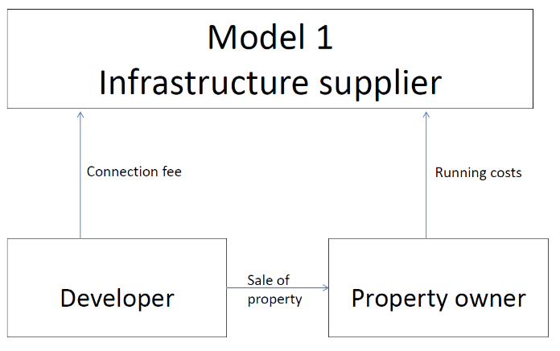 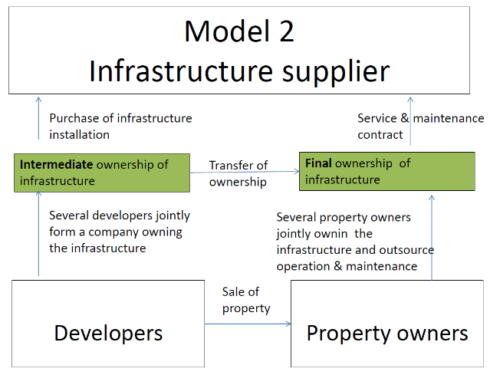

In both of these models, the infrastructure supplier has a long-term business model by using operation and maintenance fees to finance both the installation and continued operation costs. The reason Model 1 is chosen for most of the infrastructure projects is because the infrastructure suppliers are public companies or private-public companies.

The advantages of Model 2 are that financial risks are reallocated to different parties depending on the stage of development. The developers bear the risk when they are developing the land but have the greatest incentive to manage this risk since they can sell the property. Then, the property owners bear the risk of the infrastructure once they obtain the property from the developers.

## 5.4 Funding Mechanisms for Environmental Programs

The funding bodies for the Hammarby Sjöstad project include the City of Stockholm, Stockholm Transport, the National Road Administration, and private funding. Major funding allocations distributed through the City were received from the national government through the Local Investment Program (Stockholm LIP, 2003).

### 5.4.1 Funding from the Local Investment Program (LIP)

The LIP represents Sweden’s largest single environmental initiative. The Swedish Parliament earmarked SEK 6.2 billion (for all of Sweden) in grants for LIPs over the period 1998–2002 with the aim of improving ecological sustainability. The national government used LIP as an incentive to encourage consideration of ecological and sustainable dimensions for future developments. This approach came from Habitat II, the 1996 United Nations Conference on Human Settlements in Istanbul, which stressed urban policies and local and regional partnerships for future sustainable development. By the Istanbul conference, each of Sweden’s 288 municipalities had already started work with Local Agenda 21, so it was natural that the program would be anchored at the local level (Gaffney et al., 2007). The programs covered all aspects of sustainability including improving energy efficiency, increasing renewable energy, ensuring proper treatment for air and water emissions, increasing biodiversity, and creating livable and sustainable residential areas.

In 2002, the Climate Investment Program (Klimp) replaced the LIP. Klimp maintained the premiums from LIP but had a stronger focus on measures to reduce greenhouse gas emissions and improving energy efficiency (SEPA, 2005).

*Figure 2. Breakdown of LIP Funding Across Sectors in Sweden. Source: Swedish EPA and IEH, 2004.*

The LIP stated that municipalities could apply for the subsidy if they employed measures that promoted ecological sustainable development. The measures would be eligible for the subsidy if they:

• Reduced the environmental load;

• Increased efficiency in energy and other natural resources;

• Promoted the use of renewable raw materials;

• Increased re-use and recycling;

• Helped conserve and strengthen biological diversity and safeguard cultural environmental value;

• Enhanced the cycling of plant nutrients and improved the indoor environment regarding allergenic substances (Gaffney et al, 2007).

The figure below shows the application process. It starts with the local actor (found in the upper left corner), and then goes through various review processes before a subsidy is granted.

*Figure 3. Process of Applying for a Subsidy from the LIP. Source: Bylund, 2006.*



The national government identified several requirements associated with the subsidy. The government’s conditions for the Stockholm LIP (SLIP) are summarized below:

• The subsidies constitute a fixed part of the project’s sum total with a maximum amount;

• Disbursements are carried out annually (for 80 percent of the subsidy);

• The remaining 20 percent is distributed after the timeframe for the project has ended, that is, the year 2001;

• The progress of the project is to be accounted for annually, any deviations and changes in the projects that may occur must be reported;

• Repayment is required for non-realized projects.

*Figure 4. Breakdown of LIP Funding Across Project Types in Sweden* (SEK Million)

As shown above, the majority of the subsidy (67% of the SEK 400 million) was earmarked for development and demonstration projects. The remaining 33% was to be used to encourage better buildings, procure technology, develop the ELP (Environmental Load Profile, explained in Section 3.2), and for information sharing.

LIP was identified as important in achieving the operational goals of the environmental program for Hammarby Sjöstad. The LIP supported the following projects:

* **Central Wastewater Treatment Plant:** The LIP supported the construction of the Hammarby Sjöstadsverk, the central wastewater treatment plant in Stockholm that was next to Hammarby Sjöstad, where methods were developed to improve wastewater treatment both in Hammarby Sjöstad and in other districts.
* **Biogas technology:** LIP was also the catalyst for Stockholm Water to invest in biogas solutions. In turn the investment from Stockholm Water has led to technological development, reduced energy consumption, lower emissions and wastewater treatment plants have become sources of renewable energy for Hammarby (The Environmental Protection Agency, 2008). Two biogas plants are being built with the money from LIP, one located north west of Stockholm in Bromma and one in the Hammarby area near the Henriksdals WWTP. One aim of the plants is to is to increase production of purified biogas for vehicle fuel. Another aim is to reduce the treatment plant’s energy consumption and carbon dioxide emissions by replacing fossil fuels with biogas (The Environmental Protection Agency, 2008).
* **Other technologies:** The LIP also helped to initiate the installation of solar cells, solar panels, fuel cells, biogas stoves, green roofs, and local stormwater treatment in Hammarby Sjöstad (Brandt & Pandis, 2011).

### 5.4.2 Funding from the City of Stockholm

The City of Stockholm allocated about SEK 400 million (42 million Euros) to aid projects in three eco-districts: SEK 200 million for Hammarby Sjöstad and SEK 200 million to be shared by Skärholmen and Östbergahöjden.

*Figure 5. Breakdown of Funding from the City of Stockholm. Source: Bylund, 2006.*

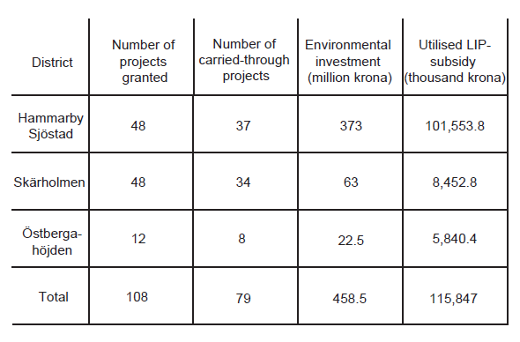

The aim of the initiative was to make the three selected neighborhoods into eco-friendly developments shown in Figure 5. At that time Hammarby Sjöstad was under construction and was therefore chosen together with the existing areas Skärholmen and Östberga. The areas were to be pilot projects on how to learn to develop effective and comprehensive solutions for sustainable urbanization. As mentioned earlier, Hammarby Sjöstad’s goal was to become “twice as good” compared to existent developments. Skärholmen and Östberga were to planned to be 30% better than the average conditions when the LIP project began (LIP Stockholm, 2004).

The environmental investments (from the national government, the City, and private actors) amount to about 2.5 billion SEK broken down as follows:

Table 8. Environmental Investments from Various Parties (*Source: LIP Stockholm, 2004)*

|  |  |  |
| --- | --- | --- |
|  | **Government Grants (SEK, millions)** | **The City of Stockholm and Private Companies (SEK, millions)** |
| *Eco-Cycle Cities* | 400 | 1500 |
| *City Administrations and Companies* | 200 | 340 |
| *Specific Area Projects* | 35 | 35 |

The eco-cycles cities represent the three neighbourhoods: Hammarby Sjöstad, Östberga, and Skärholmen. Examples of the city administrations and companies are Stockholm Water, Fortum, and Environmental Health Committee. Specific area projects included grants for markets with locally produced food and increasing the amount of energy information provided to residents (Stockholm LIP, 2003).

1. Liquidated damages (in Swedish *vite*) are monetary amounts that have to be paid on demand from a court or other authority if the developer has failed to comply with the City's decision.
2. This is referring to ownership issues regarding larger waste collection systems. Collection of household waste is a municipal monopoly in Sweden. However, several municipalities do not view vacuum waste systems as infrastructure that the municipality should own and operate. They argue that it is an extension of the waste system for a building and that their responsibility begins when it is time to empty the containers at the central container station. The developers themselves pay the investment for building out the system and then hand it over to the building associations to own and operate.