THE DEVELOPMENT PROCESS
“The city’s total expenditure on the project amounted to about 500 million Euros. The total volume with developers is about 3,000 million Euros (2,500 million Euros from the developers) for the whole area which means that developers took the greatest risks. But still we think this is the most profitable way for the city [to develop] so we get more taxpayers and at the same time the city is growing.” - Lars Fränne, Head of Planning, Stockholm City
This section describes and provides insight into the entire development process for Hammarby. From national government policy to design guidelines for individual buildings, this section explicates how macro and micro processes came together in Hammarby’s development.

- The first section looks at the roles and responsibilities of the national, regional, and municipal governments in the planning process and how each level of government contributed to the sustainability goals.
- We provide a high-level overview of the planning process in general, outlining the urban planning and development process and the standard procedure.
- We look at the specific master planning and land development process for Hammarby. This section will look at how the Project Team managed the planning and land development process.
- This section looks at property development and how developers were involved in the process.

4.1 Role of the National, Regional, and Municipal Governments in Planning
This section looks at the role of the national, regional, and local government in the planning process and how responsibilities were divided. The figure below shows the high-level overview of the planning process from the national to municipal government.

Figure 1. Sweden’s Planning Structure (Source: Authors).
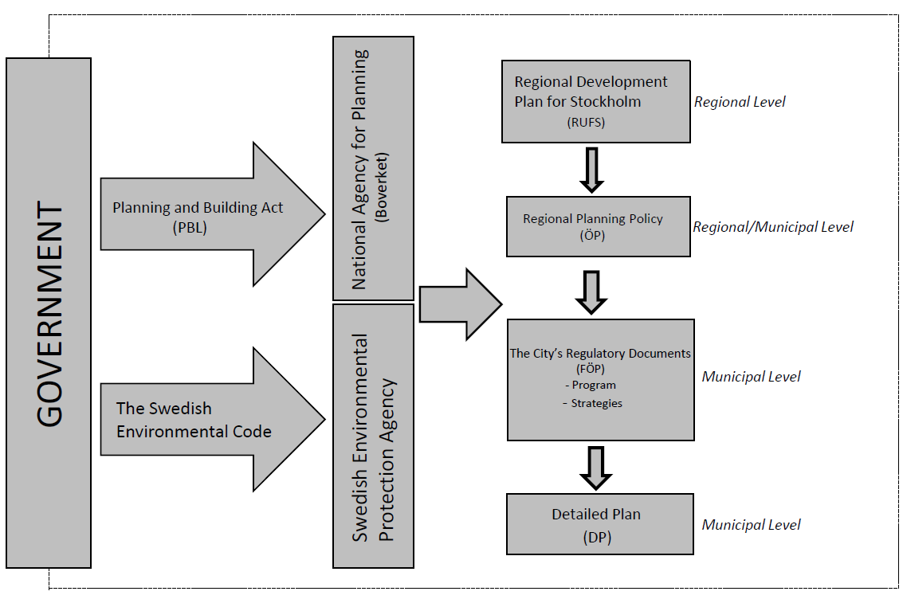

Sweden is a parliamentary democracy. The country is comprised of 21 counties, which are further divided into 289 municipalities, one of which is Stockholm. This means that there are three levels of government that influence Stockholm. Cooperation between each level of government is common due to the centralized configuration.

4.1.1 The National Government’s Impact on Planning
Boverket is the national agency for planning, the management of land and water resources, urban development, and building and housing. As Figure 15 shows, the Swedish government is in charge of the Planning and Building Act (PBL}, which Boverket takes into account when guiding the Swedish municipalities. Under the Planning and Building Act and related legislation, Boverket monitors the function of the legislative system and proposes regulatory changes. The agency also represents Sweden in the European Commission, and works for the implementation of EU directives in Swedish legislation. The government’s sustainable development policy informs Boverket’s work especially in terms of housing, construction, and urban development. Figure 2 below shows the interconnectedness of the Planning and Building Act and the Swedish Environmental Code.

Figure 2. Overview of the links between the Planning and Building Act and the Environmental Code (Source: The SymbioCity Approach, 2011).
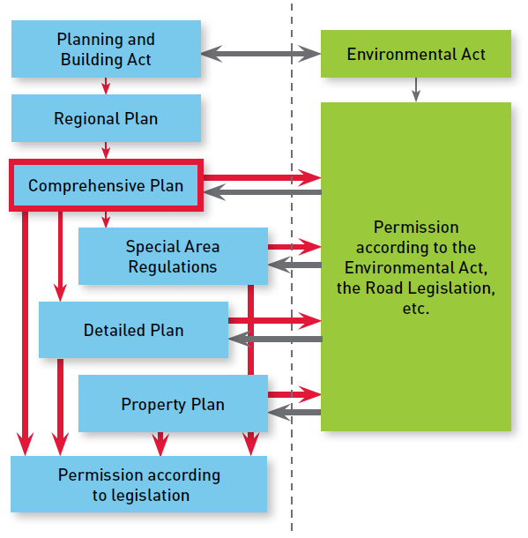

The Regional Development Plan for the Stockholm Region (RUFS) sets out the general development vision for the area. General Plans (ÖP) and In-depth General Plans (FÖP) are not binding. The Detailed Plan, conducted by the municipality is the legal document which guides the development process.

4.1.2 The Regional Level
Within each of the 21 counties in Sweden there are two organizations with different obligations: the County Council and the County Administrative Board. The County Council is an elected body and is financed by County Council taxes. It is mainly in charge of medical care (including dental care and hospitals), but it is also responsible for regional public transport.

The County Administrative Board (Länsstyrelsen) is the regional office for national administration and policy. The board is obliged to carry out national policy at the regional level: administrating civil defense, social security, transport, food and drug control, animal protection, agriculture and fishing, gender equality, cultural heritage, housing subsidies planning, and environmental protection.

4.1.3 The Local Level
The municipality is in charge of social services, schools, recreation, streets, and parks. Urban planning, building permits and housing are also responsibilities of the municipality. The municipalities are autonomous from the national and regional government in that they can determine their own tax rates. Municipal tax rates are higher than the national and county taxes. For example, the Swedish income tax is almost entirely municipal. The municipality essentially has monopoly control over the planning process, which means that the municipality decides on the urban plans. Unless appealed, the county administration can only object on very limited aspects of plan proposals (National Board of Housing, 2013).

Table 1. Examples of Income Tax Rates Per Month (Source: SCB, 2015)
 | County Council Tax | Municipal Tax | Total Tax
Sweden | 11.29% | 20.70% | 31.99%
Stockholm region | 12.10% | 18.43% | 30.53%
Gothenburg region | 10.18% | 22.56% | 32.74%

Each municipality creates a comprehensive plan that covers the entire municipality and includes basic features of: land use, water use, and development (both new construction and conservation). The comprehensive plan must also show how national interests are to be accommodated within the municipality’s plan.

The Planning Authority is responsible for the city's physical layout including master planning and zoning, building permits, and building applications. The City Planning Administration operates under the Planning Authority, which is responsible for putting the decision into practice (Skillbäck, 2015). The Planning Authority creates the Detailed Plan, the legal document that dictates land-use and building development more specifically. The Detailed Plan includes provisions for new settlements, changes to the existing environment, and introducing certain building permits (Skillbäck, 2015).

The scheme below shows a timeline of the coordination between the different administration offices on the local level within the City of Stockholm for development on city land. The process begins with the creation of the Detailed Plan which leads to specific construction projects. Notably, the scheme shows how the Traffic Office, Development Administration, and City Planning Administration work together at various stages in the development process. This process will be explained in more detail in the following section.

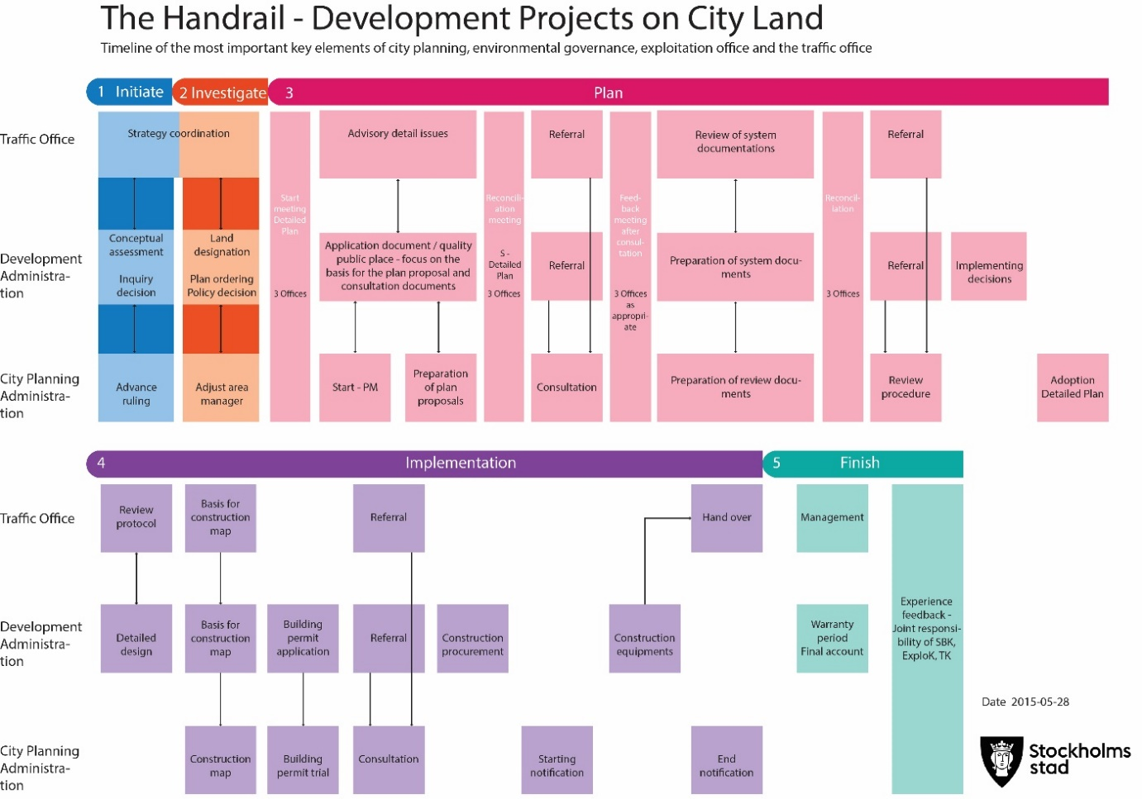
4.2 Overview of the General Planning Process
Figure 17. The Handrail – Development Projects on City Land. Source: City of Stockholm. Modified by authors
This section will look at the individual steps involved in the planning process and how the national, regional, and municipal governments are involved at each step.

4.2.1 Urban Planning and Development Process
The Urban Planning and Development Process (UPDP), is the process which a developer or municipality goes through to generate a development proposal.
Table 2. Main Actors in Hammarby’s Urban Planning and Development Process
Actor | Description
Developers | There are over 30 developers for Hammarby. The key developers are Skanska, JM, Familjebostäder, PEAB, NCC, Svenska Bostäder, among others. Please see Appendix 5 for a full list of developers and architects.
City Planning Authority | The City Planning Authority is responsible for developing detailed plans with building permits for the new buildings. The City Planning Authority and the Development Administration collaborate but they have distinct responsibilities.
Development Administration | The Development Administration is responsible for general facilities like streets, squares, and parks. The Development Administration is also responsible for land allocation, sale, and leasehold tenure of land owned by the City.

The following steps detail the urban planning and development process in the city of Stockholm:
- Idea: A proposal for new development comes from either the City or the developer(s).
- Land allocation application: If the land is owned by the City, the developer needs to submit a land allocation application to the Development Administration. If the land is privately owned, the developer needs to obtain a Detailed Plan from the City Planning Authority.
- Pre-evaluation: The Development Administration and the City Planning Authority make a common evaluation of the idea. Within three months, they notify the developer if it is possible to build in the area or not.
- Decision: In more complex projects, the Development Administration makes a decision if the project is realizable or not.
- Land allocation, target decision, and ordering the plan: If the project is feasible, the Development Administration orders a detailed plan from the City Planning Authority. If the land is owned by the City, a land allocation document is created and the Development Administration makes the decisions about the land allocation. Land allocation guarantees that the developer alone gets to negotiate with the city for the proposed land, for a certain time and under certain conditions. In some cases, e.g. within larger development areas where several developers are involved, land allocation can occur at a later stage. Land allocation can be done either through a direct land allocation from the City or be regulated by a tendering process.
- The Start: The Planning Authority makes the decision to start working on the detailed plan. As a basis, there is a Memorandum of Initiation that outlines the proposed plan, specifies issues to be addressed, and lays out the kind of planning process to be used. Before starting to work with the plan, a plan agreement between the City Planning Authority and the developer(s) is signed. This document regulates commitments from the developers as well as commitments from the City. It also determines a timetable and budget for the work.

4.2.2 The Standard Procedure
The Standard Procedure is implemented when a municipality has completed the process described above and has a proposal for the development of a specific area.
The standard planning process is regulated by the Planning and Building Act at the national government level. This act examines whether a proposed land-use decision is appropriate. In the process, public and private interests are weighed against each other. The process involves all the stakeholders that might be affected by the process and consults each of them. A number of technical departments are also given the opportunity to assess the proposal (Skillbäck, 2015).

The figure below outlines the Standard Procedure for the planning process. According to the National Board of Housing, “The standard procedure may be applied if the proposed development is consistent with the Comprehensive Plan and the County Administrative Board's audit opinion is not of significant interest to the public or otherwise of major importance. The local plan should not significantly affect the environment.”

Figure 4. The Standard Procedure. Source: The National Board of Housing. Modified by authors

This six-step process is described in detail below:

1. Consultation: The municipality, the National Land Agency, the County Administrative Board and other affected parties and residents consult on the proposed plan. During the consultation, the National Land Agency submits comments on the proposal. The County Administrative Board is responsible for coordinating the state’s interests. If the state’s interest is not met in the Detailed Plan, the municipality must redo the plan. The National Land Agency’s role is to ensure that the plan describes how the municipality intends to implement it and the potential consequences of the development.

The County Administrative Board and The National Land Agency provide a common view of the detailed development and property registration processes. The goal of this is to facilitate dialogue and cooperation between planners and property developers and resolve any property law issues in the early stages of the planning process.

2 & 3. Notification and Review: During the notification phase, the authorities, interested parties, and others affected by the plan are given an opportunity to comment on the proposed plan. At this phase, the County Administrative Board is required to state if they think the proposal might breach their provisions. The National Land Authority states if they think that not all the questions are regarded or resolved in the proposal. After the review, the municipality can make only minor changes to the proposed plan. If there are major changes to the plan, a new review shall be held.

4. Position: The municipality compiles and responds to the written comments from the notification and the review in a report. In this stage the plan becomes more precise and concrete. Questions that are handled include: risks, noise, pollution, etc. The City conducts a pre-planning of public spaces and facilities and makes a budget for the potential costs. If the land is owned by a private developer, the City explains how the public facilities should be built. The second alternative is that the developer provides a monetary contribution to the City, and then the City will build the public facilities. Once the proposed plan is ready, another joint consultation takes place. The consultation follows the same pattern as before. The “final” plan is out for exhibition for approximately three weeks. This is the last chance for other stakeholders to comment on the development.

Done in parallel with the exhibition, there is an agreement between the developers and the Development Administration. The agreement regulates access to the City's land, clarifies other responsibilities, and sets quality standards for the design, environment, and energy issues. If the land is privately owned, the Development Authority creates a contract with the developer that regulates how and who that will be responsible for the costs of the public facilities. If the developer owns the land the developer must pay the costs. If the City owns the land the Development Administration needs to pay the costs. After the exhibition, the Development Authority makes a decision about implementing the plan.

5. Acceptance: A Detailed Plan is adopted by the City Council. The City Council can also delegate the decision to the municipality or Planning Authority.

6. Legal Force: Three weeks after acceptance, the Detailed Plan gains legal force if there are no further complaints from the County Administrative Board. The Detailed Plan can be appealed to the Land and Environmental Court (National Board of Housing, 2015).

4.2.3 Implementation

Once the Standard Procedure is complete, the City proceeds with implementing the project in the following steps:

- Projecting: When the plan is accepted, the developers and the City can start with their separate detailed projects e.g. the City starts to prepare the land and the developers make sure their construction documents are in order.

- Property formation: This step is conducted by the land surveyors. If the land is owned by the City, the Development Authority can sell the land to a developer. However, the developer has to abide by all the decisions made on the piece of land.
- Building permit: A building permit is required in most cases when there is a new development or a change is being made to an existing development. A building permit should be sought in advance by the developer or other person involved in the project. The decision is made by the Planning Authority in most cases.
- Building application: This has to be filled in by the developer at least three weeks before starting site development.
- Implementation: The developer is responsible for having all the permits and contracts. When the development is completed and the City gains control, the developer receives a final document. Then residents can move in (City of Stockholm, 2015).

4.3 Master Planning & Land Development
“From my perspective, eco-governance is the unique way in which these major urban development projects are governed. This unique approach is characterized by working towards common goals and sharing data and resources in order to achieve those goals. It is also characterized by an ability to make room for new business models where both the public and private sectors can invest, and therefore share the costs and the benefits of new technologies that minimize negative impacts on society. This concept now underpins sustainable development in Sweden and has proven to be a tried, tested, and successful model.” – Jonas Törnblom

This section presents Hammarby’s design process including master planning, detailed planning, building codes, setting design codes and appointing development teams. Then it describes the management structure for the development, particularly highlighting the effectiveness of the Project Team, a cross-departmental body that led the development. The section details the management tools that aided the Project Team.

4.3.1 The Design Process
The design process involves four major steps:
- Creating the strategic master plan
- Creating detailed master plans for the sub-districts
- Setting design codes for each sub-district
- Appointing development teams to work on designated plots of land within the sub-districts. The figure below shows each of these steps

Figure 5. Hammarby Sjöstad Design Process. Source: Gaffney et al., 2007.
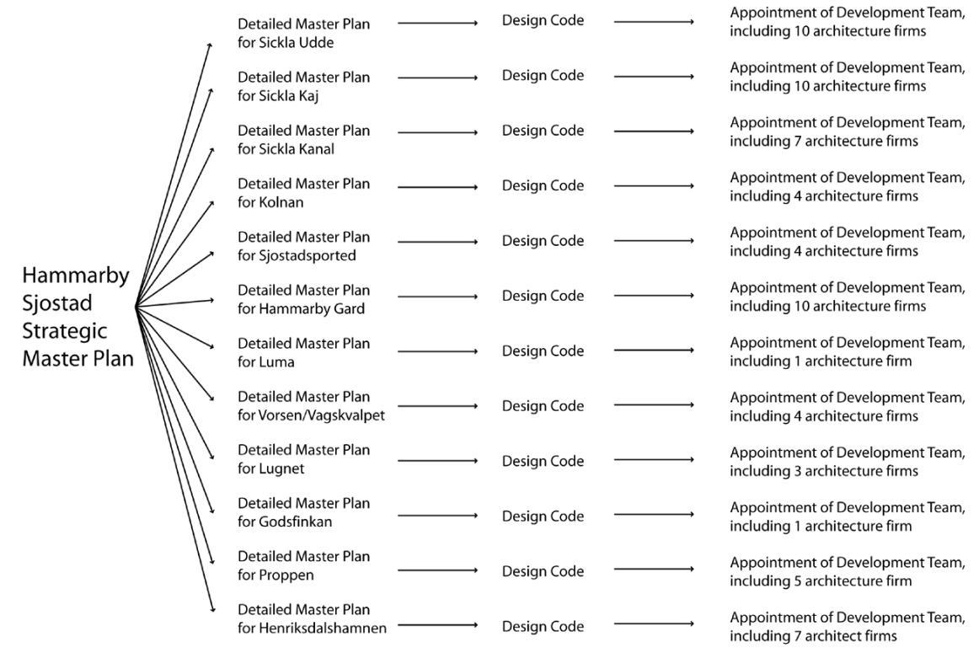
These steps are further explained below:
1. Creating the Strategic Master Plan: The design process starts with the Strategic Master Plan, the preparation of which was led by Stockholm’s City Planning Office. The plan got divided into twelve sub-districts, which are being developed in phases. Six have been developed to date.

2. Creating the Detailed Master Plans: Following completion of the Strategic Master Plan, the City selects three to four architects/master planners in the private sector who are appointed to test the Strategic Master Plan and draw up more detailed proposals for the sub-district. A design process termed “parallel sketches” has been adopted in the preparation of Detailed Master Plan for each sub-district. The chief planner at the City Planning Office responsible for Hammarby Sjöstad emphasizes that they try to choose new architects for each sub-district, where possible, and that they encourage young architects and up-and coming firms to take part. The City evaluates the sketches and assimilates the best features from each to arrive at an agreed upon detailed Master Plan (CABE 2007). The figure below shows the sub-districts in Hammarby, each of which has a Detailed Master Plan.

Figure 6. Sub-Districts in Hammarby. Source: Gaffney et al., 2007.
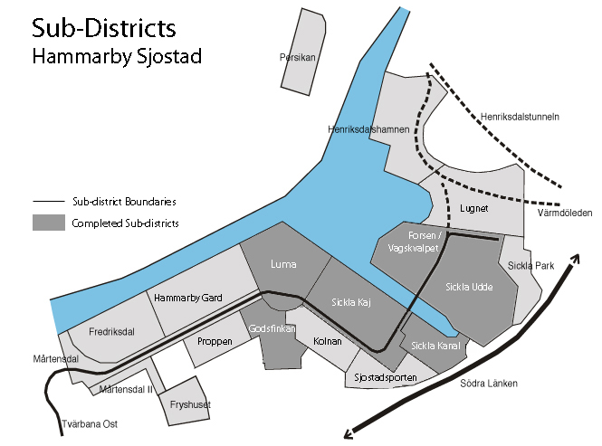

3. Setting design codes for each sub-district: To support the Detailed Master Plans, the City’s planning and design team then prepares a design code for each sub-district in close partnership with the chosen developers and architects for each plot. The design code is taken through the local authority’s political process and is added as an appendix to the development agreement between the City and the development partners. The aim is to establish a level of quality for the development that both the City and developer can agree on (CABE 2007). More details on the design codes are outlined in Section 4.5.

4. Appointment of development teams: Finally, the City invites a consortium of developers and architects to direct their attention to each plot of land or individual buildings within each sub-district. Many developers are invited in order to ensure architectural diversity, under the umbrella of a unifying code.
The diversity of design is due to the fact that each street block, and sometimes even each building and courtyard, is designed by different architects and landscape architects working closely with the individual clients or developers. Detailed conceptual building models at a scale of 1:200 were developed through a series of competitions arranged by the Stockholm City Planning Department where architecture firms were invited to submit ideas. A few different architectural firms in the private sector were appointed to develop building typologies that would be suitable for the area’s sub-districts.

Each sub-district typically has between four and eleven plots depending on the size and complexity of the development. Different teams of developers and architects develop on identified blocks. Over 30 different developers have been identified. Key developers are Skanska, Family Housing, Swedish Housing, HSB, SKB and Borätt. Over 30 different architects have been appointed and the project has involved various engineers, surveyors and contractors, which have been appointed by individual development teams (CABE 2007; Gaffney et al., 2007). This process will be described in greater detail in section 4.4.

4.3.2 General Management Structure
The design process of Hammarby Sjöstad was characterized by a high level of cooperation, collaboration, and transparency between among all parties. This is attributable to the fact that the Project Team included a variety of stakeholders. Through all the phases, from planning to development and implementation, the process included all types of stakeholders. In this way the stakeholders gained a better understanding of why things were done and how it the development would affect their interests. The Stockholm City Planning Department was responsible for the coordination of the process. Regular meetings and workshops were held and building project progress reports were submitted to all parties. During the workshops, projects were discussed openly in a friendly atmosphere.

4.3.3 The Project Team
The development of Hammarby Sjöstad has involved a variety of actors: several city administrations; the municipal companies for water, waste, and energy; and the regional public transport company Storstockholms Lokaltrafik (SL). Private developers, municipal housing companies, architects, and other consultants also played important roles (Svane et al., 2011).

In 1997, the city authorities appointed a Project Team composed of staff from two different organisations: the City Planning Administration and the Development Administration of Stockholm. Both of the administrations assigned staff specifically to the Hammarby project to collaborate with developers, architects, public sector stakeholders, and Stockholm residents (Svane, 2002). This group consisted of eleven people and had their own project office at the site. Kerstin Blix, the Project Team’s environmental manager, explained that the reason for creating the separate Project Team was due to time pressure and the high targets set in the application for the Olympics (Blix in Magnusson & Nilsson, 2012).

Figure 9. Organization of the Project Team for Hammarby Sjöstad (Source: Nilsson & Magnusson, 2012. Modified by Authors).
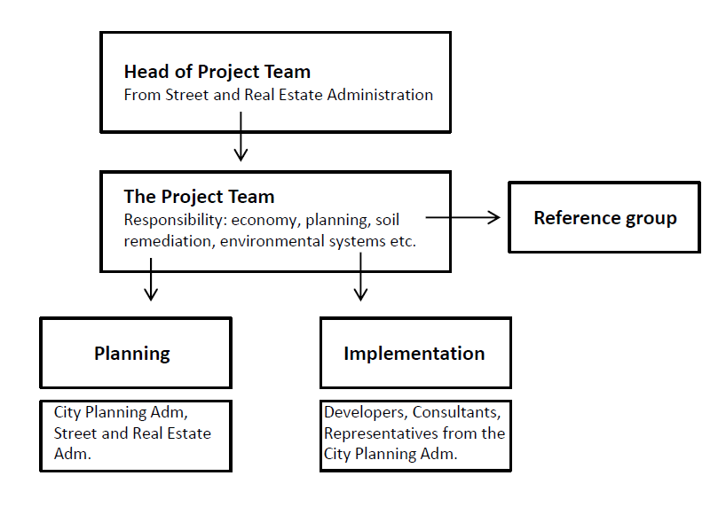
Roles and People (1997):
Head of Project Team: Leif Bergman (1997), Göran Träff (1999), Lars Fränne and Martin Skillbäck.
Head of Development Administration: Gunilla Wastesson
Head of Planning: Jan Inge-Hagström, Vice project leader: Susanne Bäckström
Head of Landscape: Kristina Menyes (från ca 1999)
Head of Environmental issues: Kerstin Blix
Head of Information: Åsa Bodén
Head of Municipal service: Björn Cederquist
Head of Implementaion: Erling Magnusson (Source: Bäckström, 2015)

At first, the Project Team, was outside the ordinary organization of departments within the City of Stockholm The idea was that the Project Team should be neutral in its contacts with the other companies and departments, and thus serve as an effective mediator if conflicts or disagreements were to arise. However, one disadvantage was that the main part of the City’s estimated investment – SEK 2 billion – would be directed the ordinary way, out of the team’s control. In 1998, the political majority shifted, and as a result the Team became part of the City’s Streets and Real Estate Administration (Svane, 2002).

The Project Team was responsible for planning, finances, land decontamination, and construction of bridges pipes, streets and parks within the district (Bäckström, 2015).

The City’s directive to the Project Team was that they should guide and influence all stakeholders, public as well as private, to realize the environmental objectives of the project. The City’s politicians decided on the environmental objectives. Its administrations and companies, the municipal and private developers, and the contractors and consultants were jointly responsible for realizing the objectives (Svane, 2002).

Figure 8. Model for Hammarby Sjöstad made by the City Planning Department. Source: Authors
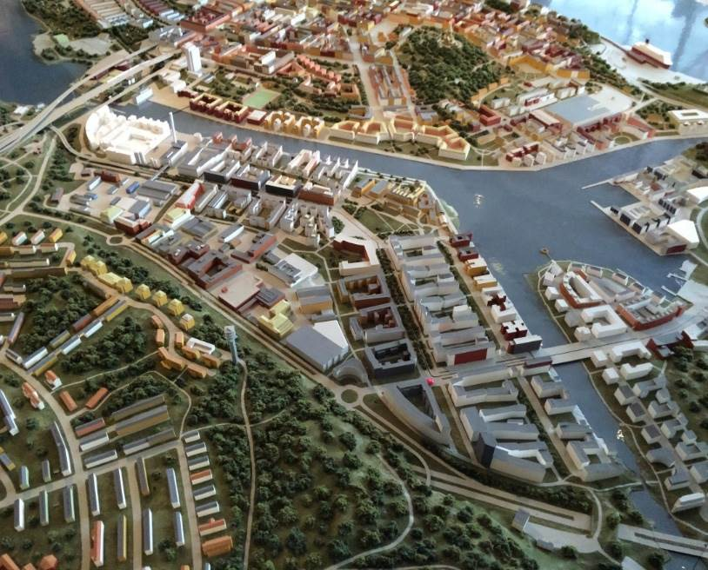

4.3.3 Management Tools
The Project Team used three main channels to manage the project: their authority in the Streets and Real Estate Administration, plans and building permits, and the Environmental Load Profile.

Since the Project Team had authority in the Streets and Real Estate Administration, the Project Team could influence developers and future real estate owners. For example, this could take place through development contracts negotiated through the Streets and Real Estate Administration. Beyond this, the Project Team could also use plans and building permits to enforce and manage the planning process (Svane, 2002).

The Environmental Load Profile, discussed in Section 3, was also an important tool for management. The first calculations utilizing ELP were made in the summer of 2000. During the competition arranged by the Team for the developers, it was extensively used as an evaluation tool. Later in the process, the ELP will also quantify to what extent the developers and contractors succeed in realizing the project’s environmental objectives. By then, the ELP is also expected to highlight the outstanding ideas and solutions, and to inspire further improvements in the later phases of the project (Svane Ö 2002).

4.4 Property Development
This section focuses on the development process of Hammarby Sjöstad and on the developers’ role. It also presents how the City and the Project Team attracted developers. One main reason for the success of Hammarby was the smooth transitions and interactions between the planning, development, and implementation processes.

4.4.1 Policies towards Developers
Regarding land-usage, developers are regulated in the following aspects:
- The developers must undertake the design and construction of the land area to meet the City's general requirements.
- In addition to the City's general requirements, builders in Hammarby Sjöstad shall meet the requirements and pursue objectives in accordance with the Environmental Program for Hammarby Sjöstad.
- The developers must provide energy data on the development process to the city.
- City development contracts also regulate water and waste policy.

4.4.2 Attracting Developers to Hammarby Sjöstad
Hammarby’s inherent characteristics attracted developers, but the Project Team and the City also created incentives to attract developers. Inherently, developers were attracted to work in Hammarby for a few key reasons:
- Ambition to create a cutting-edge and sustainable reputation: Developers were attracted to the idea of being involved in the building of one of the world’s first large-scale eco-friendly neighborhoods and creating a reputation for themselves around sustainability.
- Location: The location chosen to prevent sprawl was close to the inner city of Stockholm since it was an infill development. This location ensured that the area would attract residents and businesses.
- Ease of access to utilities: The location and relevant policies also made it easy to connect to the water and and electricity grid, which can often be a huge headache for developers (Skillbäck, 2015).

Moreover, the Project Team used initial funding, competitions, discussions, and negotiations to attract and engage developers.
1. Initial funding: Early on in the environmental management process, the City’s politicians promised SEK 200 million (22 million Euro) to finance the extra costs of environmental measures and technologies. This attracted many developers to the project even though the funding ended up not being available to developers. The funding was instead used for innovations related to the Hammarby Model.

Somewhat later, the national government offered the LIP subsidy for investments in environmentally friendly technology (Svane, 2005). When the City sells land as part of a development agreement, the price is part of negotiations.

2. Competitions: In order to inspire the developers, the project team held two competitions: The Best Proposition and the Greenhouse for Creative Ideas competitions. Following each competition, the City worked on compiling and disseminating the ideas and experiences gained from the competition. A ‘Best Building’ competition was also open to all the developers in Hammarby Sjöstad. The prize money will be disbursed according to how well measurements post-construction correspond to the proposed plan (Gaffney et al., 2007).

3. Discussions and negotiations: The Environmental Officer of the team, has put significant effort into encouraging the developers and contractors. She has organized seminars, discussions on infrastructural systems, etc. She has used the ELP to gain and disseminate knowledge among stakeholders. Information documents from the City’s Environmental and Health Office have contributed too (Hult and Corner, 1998). The developers have also cooperated in compiling a report that evaluates different technical solutions that might comply with the environmental objectives (Svane, 2002).

Bäckström's (2012) experience shows that developers could be more involved in the environmental initiatives. She believes that a persistent problem is the short timeframe during which developers are involved. This is also emphasized by Kerstin Blix, the Environmental Manager for the project. Many developers just build to sell with a contract period of two years. Sustainable investments often do not result in short term economic benefits, but rather become profitable after a longer period of time. If the contract period could be extended to 10 years, the developers might be more invested in the environmental initiatives. Blix's experience in the Hammarby Sjöstad project shows that if developers were contracted to also manage their buildings rather than just construction, they were more eager to spend more time and effort on the environmental initiatives (Magnusson & Nilsson, 2012).

4.4.3 Choosing the Developers
When choosing a developer, the City of Stockholm takes into account the developer’s economic status, stability, and interest in long-term management of the building. The City also takes into account how the developer has met the City´s requirements for land allocation policies in previous projects. A third element that the City considers is how the developer’s work will contribute to a more prosperous market.

The conditions for land allocation are outlined below.
- A land allocation is limited to two years from the Development Committee’s decision. If a binding agreement of usage cannot be met in these two years the City ​​makes a new land allocation. The Development Administration may grant an extension. A condition for extension is that the developer actively pursued the project and the delay is not attributed to the developer.
- A land allocation may be withdrawn during the specified period if the developer violates any of the City’s requirements or if the developer and the City cannot agree on the price.
- The developer is responsible for all financial risks associated with detailed design planning. Any design planning that has a connection with the planning work should be made in consultation with the city.
- Projects canceled due to a decision during the detailed planning process have no right to compensation or new land allocation as compensation.
- At the City's request, the developers have to build special housing, facilities for children and the elderly, as well as certain types of dwellings.
- Land allocation may not be transferred without the City's permission. This also applies transfers to affiliated/daughter companies.
- The recipient of land allocation for the tenancy shall have contracts or concluding agreements with the housing office in connection with instructions.
- The developer must follow general requirements of City Council or the Development Committee. For example, they might request that the developer integrates various forms of social housing and custom homes in new housing (Administration Development, Land Allocation Policy).

This is discussed more in Section 4.6.5.
As of now, we know little about how and to what effect the formal environmental tools just mentioned have been used.

